PROJECT REPORT FOR BACHELOR OF SCIENCE IN COMPUTER SCIENCE AND INFORMATION TECHNOLOGY

**SAVOR BITE**



**BIDHATA DEV THAKUR**

**BINAYA POKHREL**

**RAVI SHANKAR SAH**

**SAMRIDDHI COLLEGE**

**DEPARTMENT OF SCIENCE AND TECHNOLOGY**

**SEP, 2023**

PROJECT REPORT FOR BACHELOR OF SCIENCE IN COMPUTER SCIENCE AND INFORMATION TECHNOLOGY

**SAVOR BITE**

**SUPERVISED BY Er. JAGDISH ADHIKARI**

**FACULTY, SAMRIDDHI COLLEGE**

A REPORT SUBMITTED

FOR

SECOND SEMESTER HTML PROJECT

**BIDHATA DEV THAKUR**

**BINAYA POKHREL**

**RAVI SHANKAR SAH**

**SAMRIDDHI COLLEGE**

**DEPARTMENT OF SCIENCE AND TECHNOLOGY**

**SEP, 2023**

**DECLARATION**

I hereby declare that this project entitled **SAVOR BITE** is based on my original research work. Related works on this project by other researchers have been duly acknowledged. I owe all the liabilities relating to the accuracy and authenticity of the data and any other information included here under.

Bidhata Dev Thakur

Binaya Pokharel

Ravi Shankar Sah

Date: 2023-08--27

**RECOMMENDATION**

This is to certify that this project entitled SAVOR BITEprepared and submitted byBidhata dev Thakur, Binaya Pokharel, Ravi Shankar Sahfor Second semester HTML Project of Bachelor of Computer Science and Information Technology awarded by Tribhuvan University, has been completed under my supervision.

**MR. JAGDISH ADHIKARI**

Faculty, Samriddhi College

Date: SEP, 2023

# ACKNOWLEDGEMENT

First of all, the member that we would like to thank is Samriddhi College, for providing this excellent opportunity to participate in this project. Also, we would also like to thank the faculty for utilizing this minor project model to consolidate our knowledge on HTML and many concepts that are associated with it. We would also like to extend our thanks to our faculty members Mr. Jagdish Adhikari and Mr. Bikal Adhikari for sharing their invaluable knowledge and providing guidance on this particular topic. Furthermore, we would also like to thank our principal Mr. Sandeep Shrestha, along with Arpan Maskey sir and Lok Nath Regmi sir for providing us with the environment and facility so that we could complete the project on time without any time constraints and any pressures. Lastly, we would also like to thank our seniors and friends who have contributed their time to our project by helping us proof read, debug and guide us along the way. This endeavor wouldn’t be successful without the involvement of these parties and although not named we would also like to thank anyone remotely associated with this project and we would like them to know that their helps and advice have been invaluable in this endeavor.

# ABSTRACT

The " SAVOR BITE " is a website program written in the HTML language with the goal of facilitating the user to view and order their fooding through visiting our websites. The project offers a user-friendly interface that makes the user easier for accessing the website.

The primary goal of the website is to offers an exciting presentation of the restaurant menu, complete with descriptions and prices, also including mouthwatering images of the dishes.it also provides the faculty of allowing customers to place order and make reservation online, eliminating the need of in-person visit and phone calls.

You can see our menu with its yummy appetizers, main dishes, and desserts. If you want to visit us, you can easily book a table, or you can get in touch with us for questions or feedback. We want every moment you spend with us to be special, and our website helps make that happen.

Keyword: *SAVOR BITE Restaurant.*

**TABLE OF CONTENT**

ACKNOWLEDGEMENT i

ABSTRACT ii

1. INTRODUCTION 1

1.1 BACKGROUND STUDY 1

1.2 PROBLEM STATEMENT 1

1.3 OBJECTIVES 1

1.4 SCOPE AND APPLICATION 2

1.5 PROJECT FEATURES 2

1.6 FEASIBILITY ANALYSIS 3

1.6.1 1.6.1 Economic Feasibility 3

1.6.2 1.6.2 Technical Feasibility 3

1.6.3 1.6.3 Operational Feasibility 3

1.7 SYTEM REQUIREMNETS 3

1.7.1 HARDWARE REQUIREMENT 3

1.7.2 SOFTWARE REQUIREMENT 4

2. EXISTING SYSTEM 5

3. METHODOLOGY 6

3.1 SYSTEM DESIGN 6

3.1.1 ALGORITHM 6

3.1.2 SYSTEM FLOW DIAGRAM 7

3.1.3 FLOWCHART 8

4. EPILOGUE 9

4.1 EXPECTED DESIGN 9

4.2 WORK SHEDULE 12

5. LIMITATIONS 13

6. FUTURE WORK 14

7. References 15

**TABLE OF FIGURE**

Figure 4.1 1 Welcome page 9

Figure 4.1 2 Start With 9

Figure 4.1 3 Most Selling Items 10

Figure 4.1 4 Order Placement 10

Figure 4.1 5 Reservaton 11

Figure 4.1 6 Reservation Form 11

Figure 4.1 7 Bottom Page 12

# INTRODUCTION

## BACKGROUND STUDY

Savor Bite, the place for amazing food, has a website that makes your dining experience even better. It uses HTML to organize their menu and make it easy to read. With CSS, the website looks pretty and work on phones and computers. It also uses JavaScript to help you find the food you want and even customize your order. Savor Bite’s website isn't just about food; it's about using computer magic to make your dining experience special.

User can see how we used computer codes like HTML to show you their delicious menu. It also includes CSS to make it look nice and work well on different devices. With JavaScript, they add cool features that help you explore the menu and even make changes to your order.

## PROBLEM STATEMENT

Adopting contemporary online technology has become important for improving operational effectiveness and customer happiness in the rapidly evolving restaurant industry. However, plenty of restaurants continue to use manual order-taking procedures and conventional paper menus, which results in ineffectiveness, accessibility issues, and a decline in customer engagement. Given these difficulties, the project's goal is to fill the gap for a strong digital solution that makes use of HTML, CSS, and JavaScript to provide a user-friendly and interactive restaurant management system. This system aims at preserving accessibility, security, and a visually appealing user interface while simplifying menu presentation, optimizing order placement, and enabling real-time updates. The project aims to deliver a comprehensive answer to improve the restaurant's digital presence, enhance client experiences, and satisfy the growing need for online services.

## OBJECTIVES

The objective of our project “SAVOR BITE” are as follows:

1. To create a HTML program to build a responsive restaurant website
2. To make that the menu system more responsive and usable across a variety of screens, which include those found on PCs, tablets, and smartphones.

## SCOPE AND APPLICATION

1. **Online Ordering**: Customers can place orders for takeout or delivery through the website, providing a convenient way to enjoy restaurant-quality meals at home.
2. **Table Reservations**: The website facilitates reservations for diners looking to enjoy an in-person dining experience, ensuring they have a table waiting for them.
3. **Menu Presentation:** It serves as a platform to showcase the restaurant's menu, complete with detailed descriptions, pricing, and visuals of dishes.
4. **Event Promotion**: Restaurants can use the website to promote special events, such as themed dinners, holiday celebrations, or live entertainment.
5. **Customer Engagement**: The website can engage customers through features like newsletters, blogs, and social media integration, fostering a sense of community and loyalty
6. **Online Payments**: Integration with secure online payment systems allows customers to pay for orders and reservations electronically.
7. **Feedback Collection**: It provides a channel for customers to leave reviews, feedback, and suggestions, helping the restaurant improve its services.
8. **Marketing:** The website can be a central hub for digital marketing efforts, including email marketing campaigns, social media advertising, and search engine optimization (SEO).

## PROJECT FEATURES

* Responsiveness.
* Reliability.
* Does not required extra unwanted hardware.
* Flexible to users.
* Sample menu design.
* Low Cost.

## FEASIBILITY ANALYSIS

### 1.6.1 Economic Feasibility

* Free IDE and open-source library will be used to develop the website.
* Android phones and laptop used to access n testing the designs.
* No additional cost of hardware n software is required.

### 1.6.2 Technical Feasibility

* Personal computer used regularly are used for coding and development
* Mobile phones and laptops are used for testing the project

### 1.6.3 Operational Feasibility

* Since we are developing a website, knowledge of browser and IDE is required.
* HTML, CSS and JS programming languages will be used.

## SYTEM REQUIREMNETS

### HARDWARE REQUIREMENT

The physical parts or components need to access the project are:

1. Personal computer with following specifications:
   * OS: Windows 7 or above
   * RAM: 2 GB or above
   * Processor: 2 GHz or above
2. Smart Phones like Android and IOS with internet connection

### SOFTWARE REQUIREMENT

Software used while developing our project are given below: -

* Visual Studio Code
* GitHub
* Browser

# EXISTING SYSTEM

In the field of restaurant website design, there are several existing systems, tools, and practices that are commonly used to create effective and appealing websites. Here are some key components of the existing system in restaurant website design:

1. **Content Management Systems (CMS)**: CMS platforms like WordPress, Joomla, and Drupal are widely used for building restaurant websites. These systems offer user-friendly interfaces for managing content, making it easy to update menus, add new photos, and create blog posts or promotions.
2. **Responsive Design**: Responsive web design ensures that restaurant websites look and function well on various devices, including smartphones, tablets, and desktop computers. This approach enhances user experience and is essential for attracting mobile users.
3. **Menu Integration**: Restaurant websites often integrate digital menus that are easy to read and navigate. This may include categorizing items by courses, dietary preferences, or cuisine types, and providing detailed descriptions and pricing.
4. **Online Ordering and Reservations**: Integrating online ordering systems and reservation platforms like OpenTable or Reservations streamlines the customer experience. This allows visitors to place orders or book tables directly through the website.
5. **High-Quality Imagery**: Visuals play a crucial role in restaurant website design. High-resolution images of dishes, the restaurant's interior, and staff contribute to the overall appeal of the site and entice visitors.
6. **SEO Optimization**: Search engine optimization is essential for driving organic traffic to the website. Optimizing content, meta tags, and schema markup can improve the website's visibility in search engine results.
7. **Social Media Integration:** Integrating social media links and feeds allows customers to connect with the restaurant on various platforms. This also facilitates sharing and engagement.
8. **Customer Reviews and Testimonials**: Many restaurant websites incorporate customer reviews and testimonials to build trust and credibility. They often link to platforms like Yelp or Google Reviews.

These existing systems and practices in restaurant website design provide a foundation for creating websites that effectively showcase a restaurant's offerings, engage customers, and drive online and offline business. Designers and developer

# METHODOLOGY

## SYSTEM DESIGN

### ALGORITHM

Algorithm:

1. Start
2. Display Welcome Page
3. Scroll Down to View Other Options
4. Select the Option to "Start With"
5. Select the Desired Item
6. Order Now Page Opens
7. Fill in the Order Form
8. Submit the Order Form
9. Display a Confirmation Message
10. Loop back to the Welcome Page (Option to start a new order)
11. End

### SYSTEM FLOW DIAGRAM

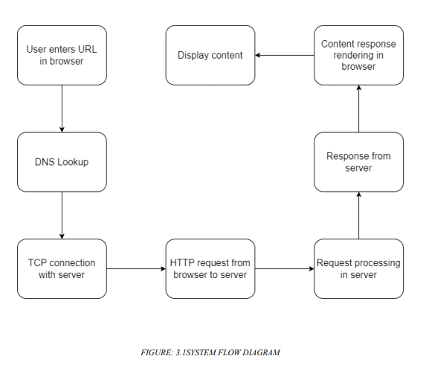

### FLOWCHART

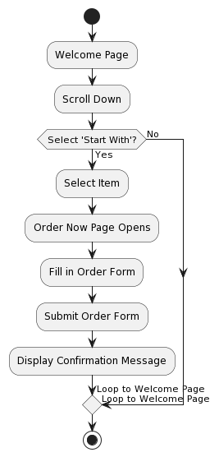

FIGURE: 3.1 FLOWCHART

# EPILOGUE

## EXPECTED DESIGN

The "SAVOR BITE " project is successfully executed or completed, as it allows a person to make order the food items from our websites.

The output of the website that displays the home page when it is executed is shown in the image below:

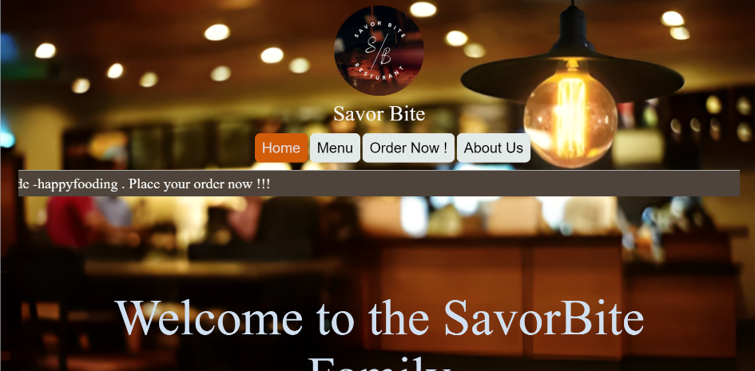

Figure 4.1 Welcome page

FIGURE: 4.1.1. shows the homepage with a welcome message. It consists of menu bar having option as HOME, MENU, ORDER NOW! ABOUT US. on clicking it, it opens their respective html document files.

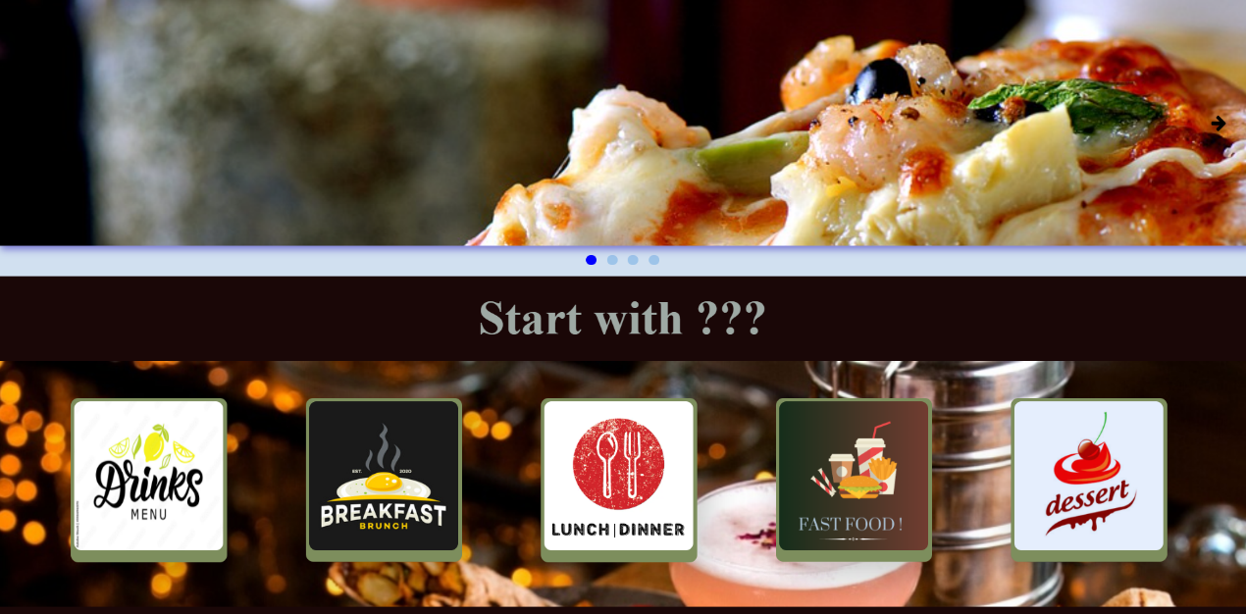

Figure 4.1 Start With

FIGURE:4.1.2. Here, it consists of a slider and the menu selector as Drinks, Breakfast, Lunch/Dinner, Fastfood and dessert. Each opens into their respective html document with list of food items.

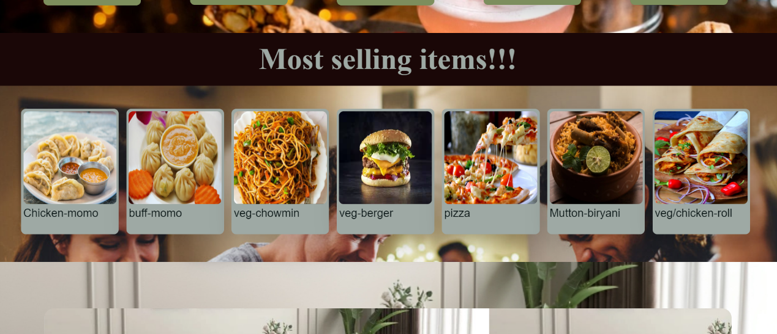

Figure 4.1 Most Selling Items

FIGURE: 4.1.3 It shows the grid view of the most selling items. it opens to order now page when we click on it.

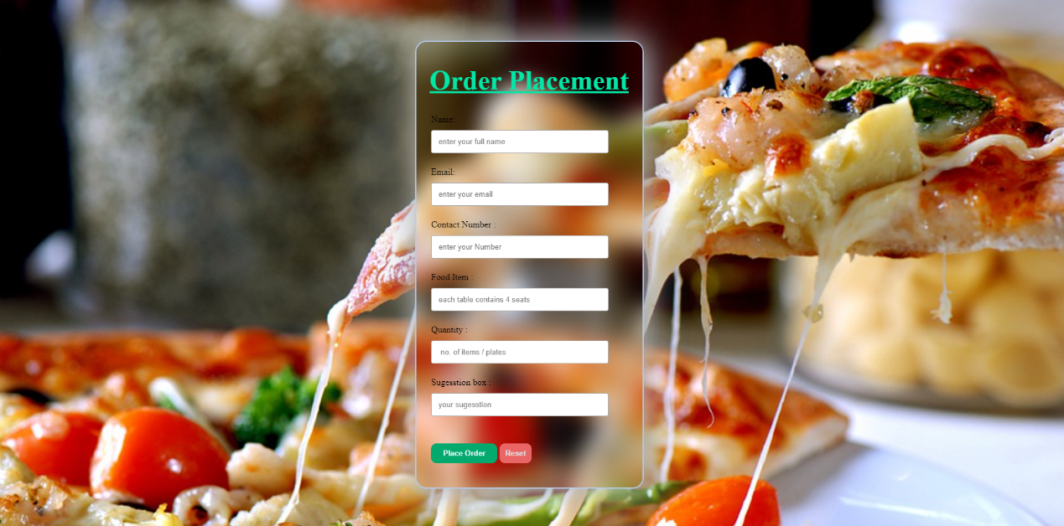

Figure 4.1 Order Placement

FIGURE:4.1.4 Here the user can place their order by filling up the from. the response of the form is collected to us and after that we contact with the user for their delivery address.

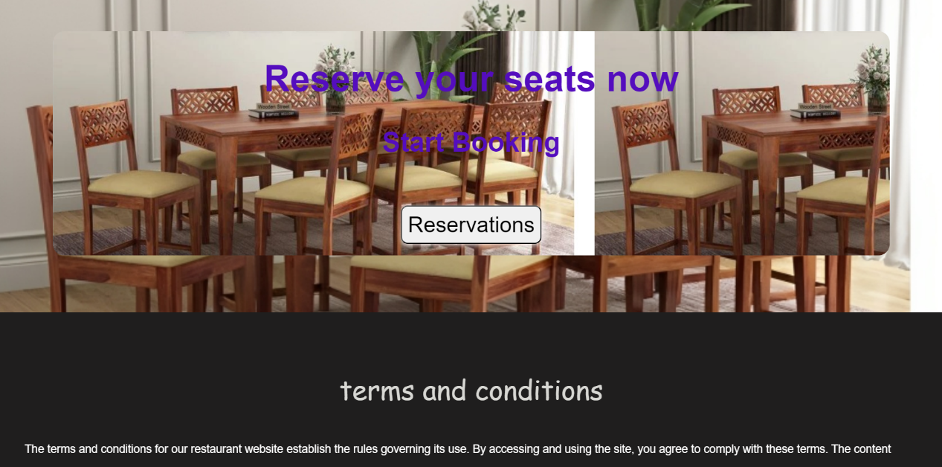

Figure 4.1 Reservaton

FIGURE: 4.1.5 shows the two parts one is for reservation and another for the terms and condition. User can book their seats by clicking on reservation button.it opens to a reservation form.

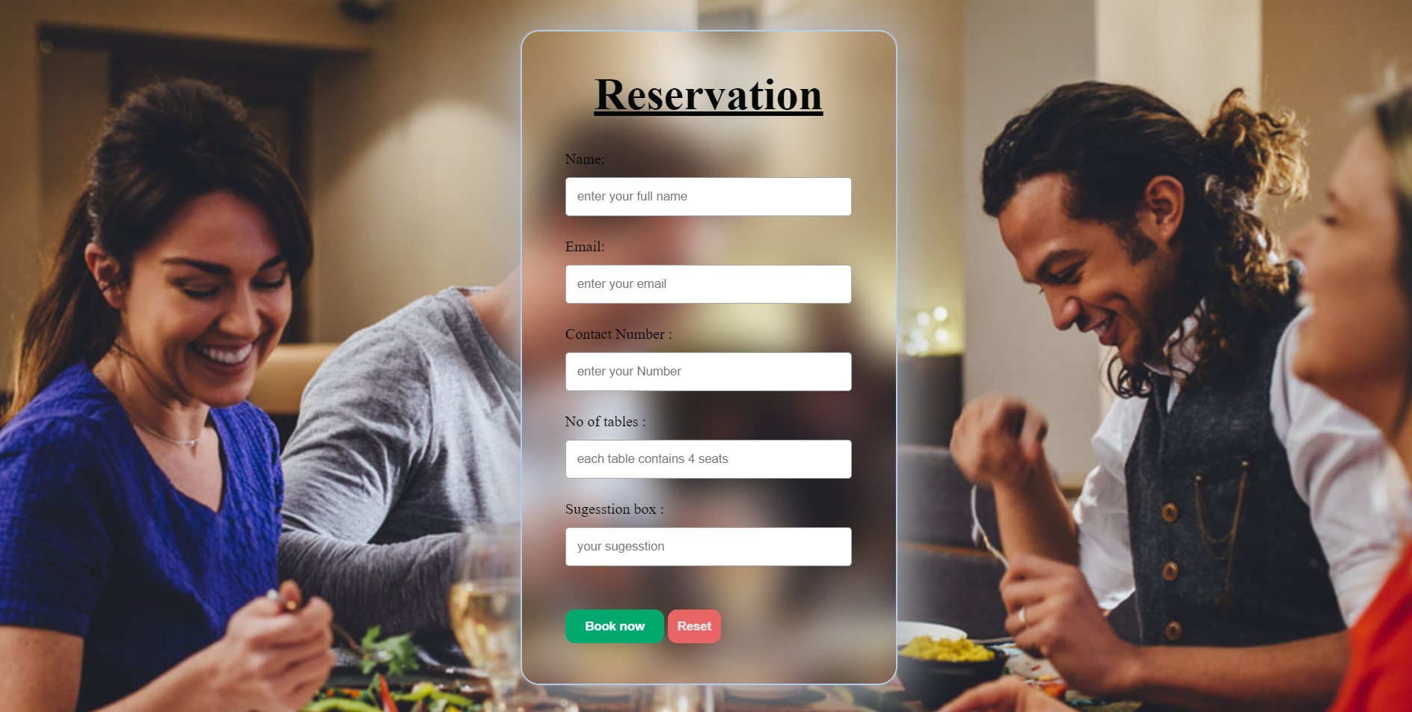

Figure 4.1 Reservation Form

FIGURE: 4.1.6 shows the reservation for the user to book their seats for the table.

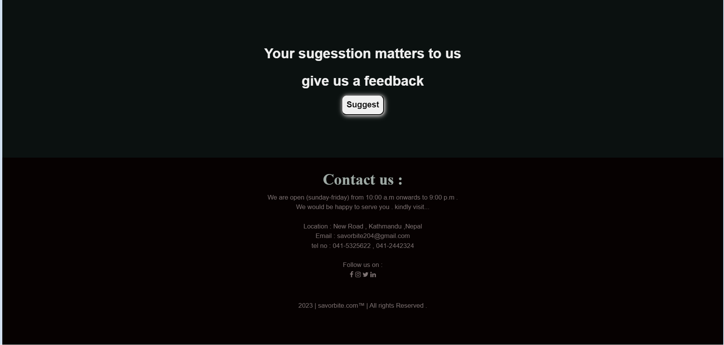

Figure 4.1 Bottom Page

FIGURE: 4.1.7 shows the feedback and contact us section. The user can give us the feedback by clicking on the suggest button. the suggest button when pressed opens a feedback form.

## WORK SHEDULE

The working schedule of the project is mentioned below in the graphical form with help of bar graph.

# LIMITATIONS

The "SAVOR BITE" project has some limitations that should be acknowledged:

* **Ineffective Marketing**: Without advanced marketing features and SEO optimization, a basic website may struggle to attract new customers. It may not rank well in search engine results or effectively engage with potential diners through social media or email marketing.
* **Inadequate Brand Representation**: Minimum requirements may hinder the website's ability to effectively convey the restaurant's brand identity, ambiance, and unique offerings. This can make it challenging to differentiate the restaurant from competitors.
* **Security Vulnerabilities**: Basic websites may not prioritize security measures, making them more susceptible to cyber threats, such as hacking or data breaches. This can compromise customer data and the reputation of the restaurant.

# FUTURE WORK

To enhance the "SAVOR BITE" project, several additional improvements can be considered:

1. **SEO Optimization:** Optimize the website for search engines (SEO) by researching keywords, creating high-quality content, and optimizing meta tags to improve its visibility in search results.
2. **Regular Updates and Maintenance:** Keep the website's software, plugins, and security features up to date to patch vulnerabilities. Regularly scan for malware and employ a Web Application Firewall (WAF) for added protection.
3. **User Data Protection:** Comply with data protection regulations (e.g., GDPR or CCPA) by clearly stating your data usage policies and obtaining consent from customers when collecting their information.
4. **Interactive Content:** Consider adding interactive elements like videos, virtual tours, or behind-the-scenes glimpses to engage visitors and showcase your brand's personality.
5. **Special Promotions and Events:** Continually update the website with information about special promotions, events, and seasonal offerings to keep it

# References

|  |  |
| --- | --- |
| [1] | P. B. a. A. G. Sebby, *The effect of online returant menus on consumers' purchase intention during the COVID-19 pandemic,* no. 94, 2021 Apr 2 . |
| [2] | K.-w. L.-S. L.-W. J. Hak-Seon Kim, *Assessing the Qualty of a Resrurant's Website,* vol. III, 2012 june . |
| [3] | N. L. R. S. Prof. Jadhav A.K, *Website Development of Resturant Management,* Vols. - 7, 2021 oct . |
| [4] | L. ,. A. ,. L. R. Madhuri, *Interactive Resturant Website,* Vols. -8, no. 10, 2021 May . |